Blackboard Grade Center: Keep Grades Current
It is essential that you keep your gradebook up to date at all times so students know where they stand and can work to succeed. An important aspect of Blackboard gradebook maintenance is entering zeros when students miss assignments and doing so immediately after a due date has passed.

The reason you must enter zeros is that Blackboard grades are calculated on a running total for each individual student. In other words, students’ points possible may vary at times if they work ahead or you grade an assignment early. However, only that student’s grade is affected, not others who have yet to complete the work. If you do not enter zeros for missed assignments, the points possible for those individuals will not change, and their grade will remain unaffected with no indication that they have missed work.

Note: Even if you accept late assignments, you should still enter zeros. This sends a signal to students, prompting them to take action if they wish to improve their grade. You can then override the zero once work is submitted.

Enter Zeros

- Go to the Full Grade Center.
- Find the column with the recently passed deadline.
- Click on the double dashes in a cell, which indicates no submission from that student.
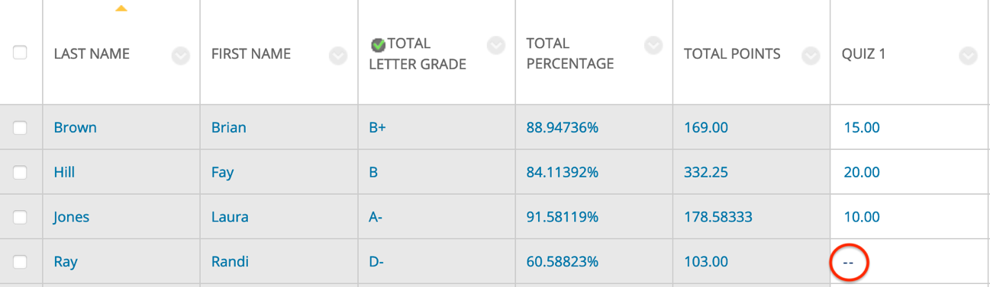
- Type in a “0” and then hit Enter on your keyboard to save the grade and move on.

Extra Tips
If you have a lot of students, you can sort the column by clicking on its title (notice the yellow triangle appear above it) so all non-submissions appear at the top. Then rapidly enter zeros without having to scroll through and search for the double dashes. Click on the Last Name column title to return to the default last name sorting.

From the Full Grade Center, you can view all total points (or weighted points) possible in your course by hovering (do not click, as Blackboard will then use the column to sort) your cursor over the name of any of your total columns. Then look to the thin Grade Information Bar that appears above the column titles. No matter the names (score/points/percentage/weighted/letter), if set up properly as a calculated total column, they should show the same points possible. Note the indication that possible points “may vary by student.” This is because students’ grades will only be calculated out of this total once all assignments have been submitted and you have entered all grades for them.
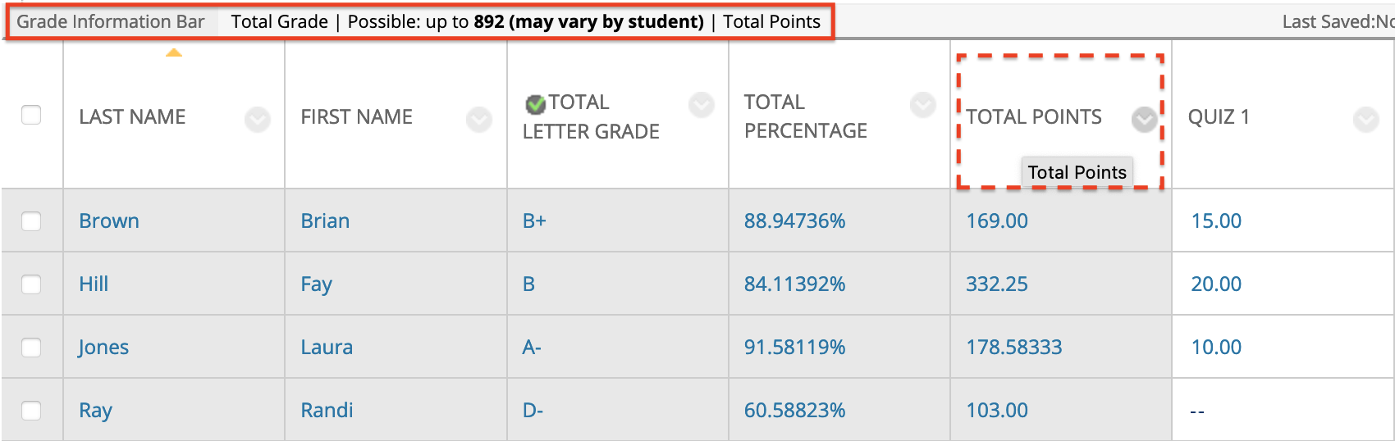

To view any individual student’s points possible and see the total their grade is being calculated out of at any point in the term, click on their total points/percentage/letter/weighted grade. Then look to the thin Grade Information Bar above column titles. As long as the column is set up as a total calculated column, it should show that student’s current, running points possible.

This tactic can help explain discrepancies in total points but similar letter grades/percentages among students in the same class or indicate where zeros need to be entered.

Example 1: Brian’s Total
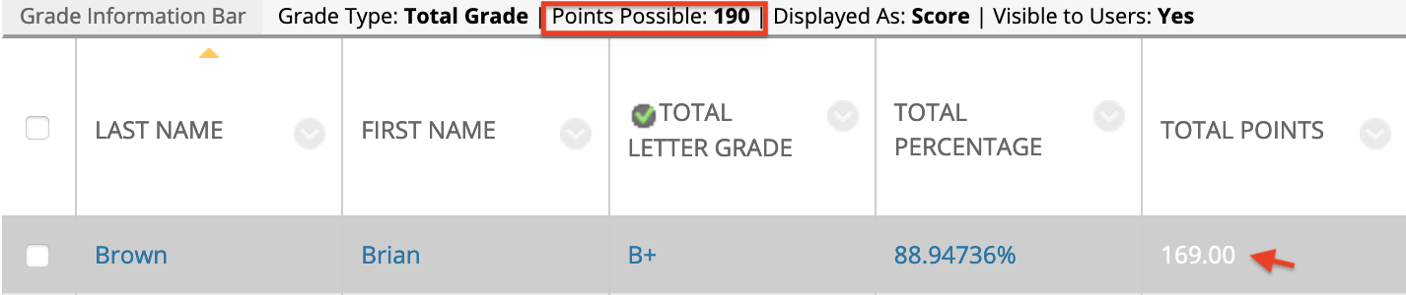

Example 2: Fay’s Total
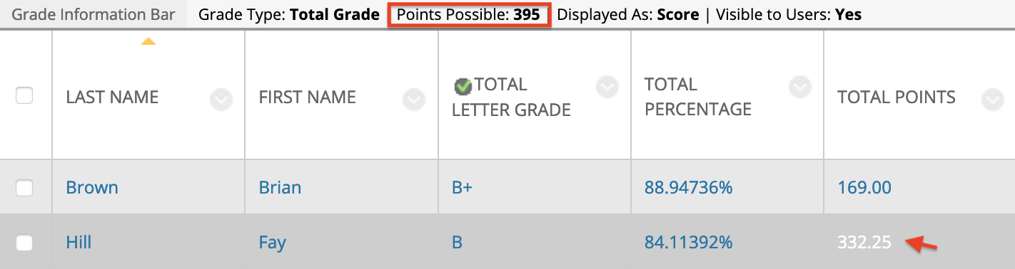
Need Help?
Contact one of our instructional designers.

